**Google reCaptcha**

1. **In first step should create reCaptcha project…:**

<https://www.google.com/recaptcha/about/>

1. **Save siteKey & secretKey**
2. **pip install django-recaptcha**
3. put in setting.INSATLLED_APPS:

**‘captcha’**

1. **Replace them in settings.py:**

**RECAPTCHA_PUBLIC_KEY = ' siteKey'**

**RECAPTCHA_PRIVATE_KEY = ' secretKey'**

1. **Add captcha to your forms:** 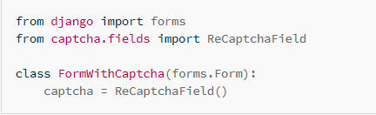
2. **Add to form template**

**{{ captcha }}**